Popock

Semantic Web in your pocket

Popock a social network based on the matching of interests, expertise, skills and projects

Tim Berners Lee's Solid project aims to provide everyone with personal storage spaces with LDP (Linked Data Platform) containers.

The user can store any type of file there, including information structured in the form of triples in turtle format. These storage spaces are named the POD (personal online database) and are accessible via a url.

This allows you to link resources (files) together, whether they are on the same POD or on a different POD.

This gives us the possibility to imagine decentralized applications.
According to Solid's specifications, it is important to separate data and applications. Thus, user data can be handled by them through different applications.

For example, a user can use the Plume application to post an article on their POD. This being saved according to a certain scheme can be read by another user with another application. (https://spoggy.solid.community/public/blog/2020-09-28.ttl )

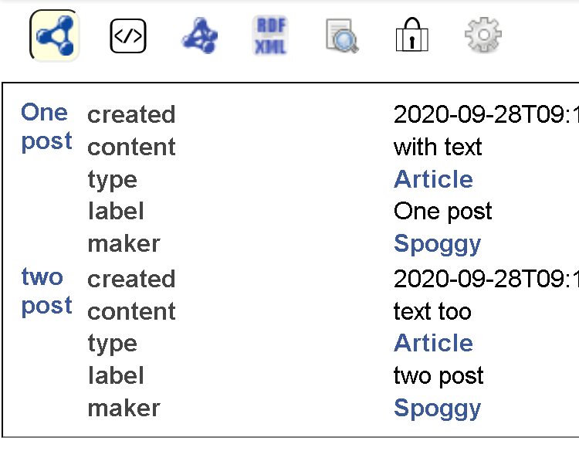 | 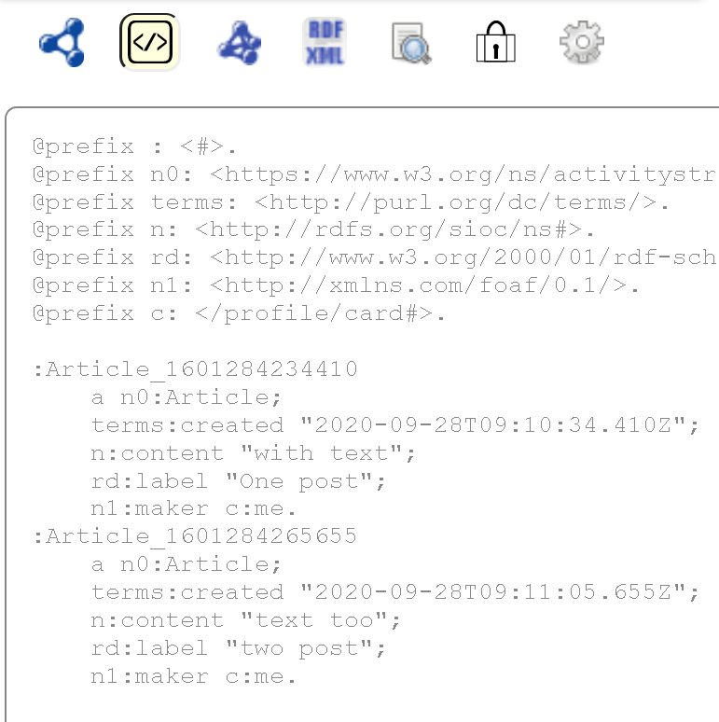

Popock

Popock aims to make it easier for a user to interact with their data, to explore the public data of their friends, or to browse knowledge bases such as Semapps, or any other triplestore such as Persée.

Popock offers, in addition to graph visualization, several interesting features based on the Semantic Web:
- a Solid profile extended by adding topics of interest (future addition of skills, soft-skills, projects, etc.)

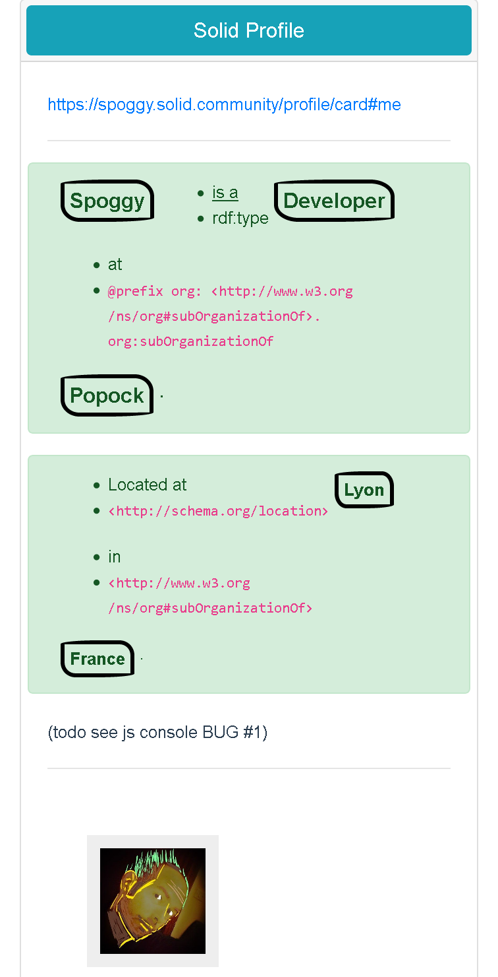 | 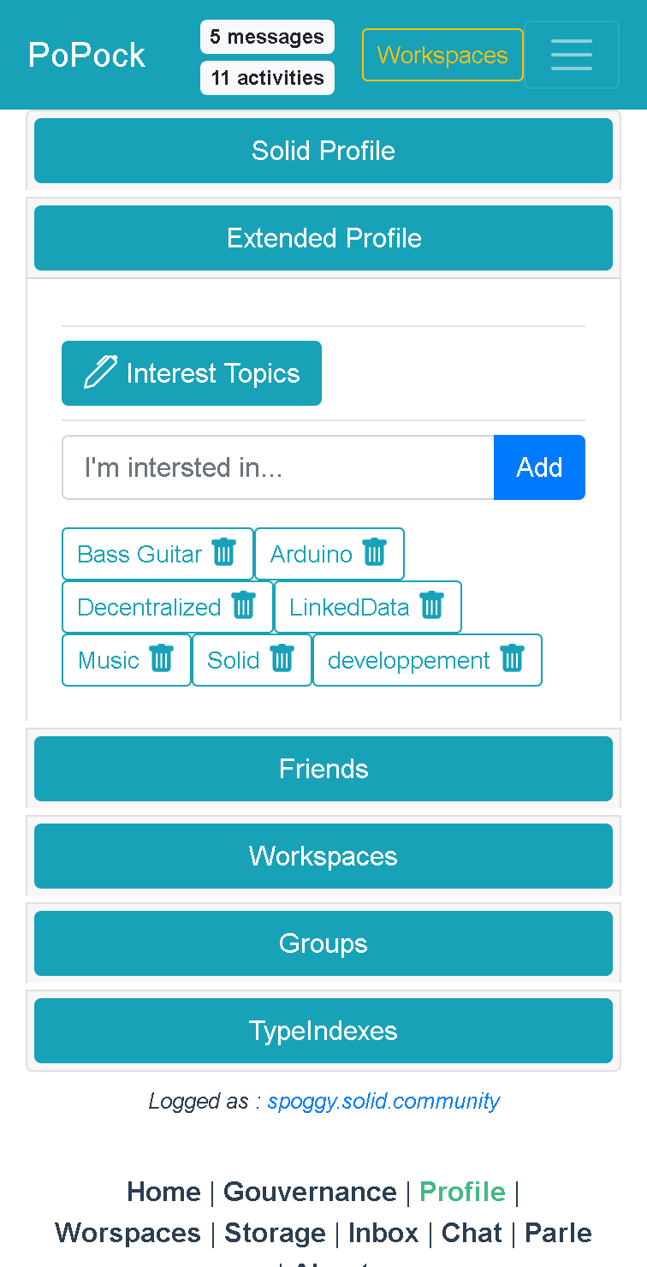

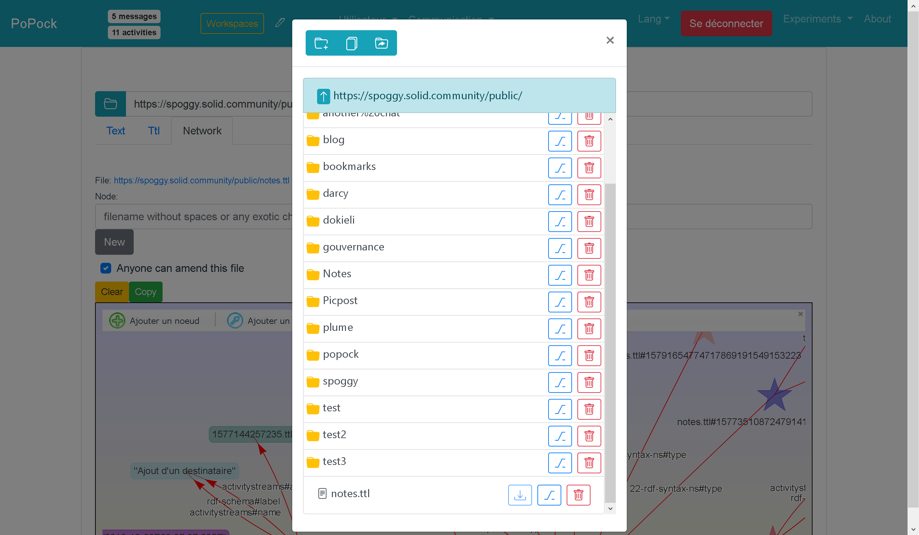
- a POD explorer similar to a file manager
- management of "friends" (foaf: kwows) exploration of their POD, bounce to their friend's PODs and so on. PODs exhibiting common interests naturally gravitate around the nodes representing these concepts on the graph.
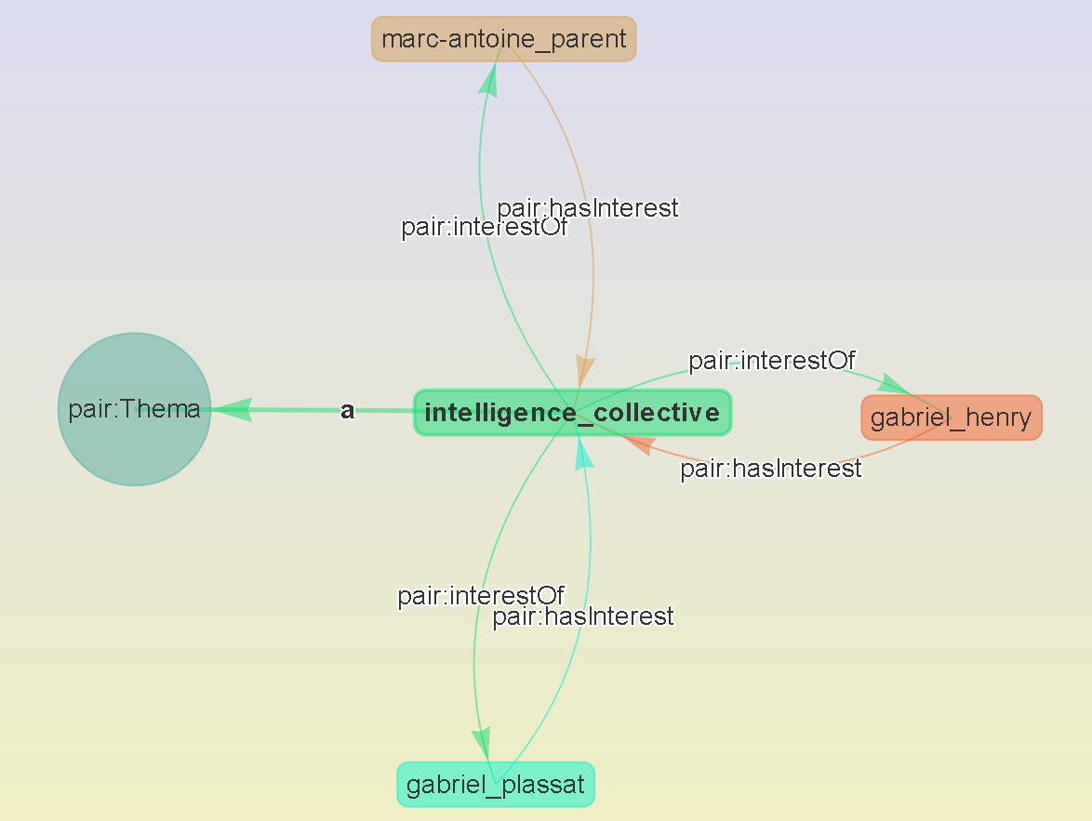

- several communication tools also based on Solid & the Semantic Web:
  - Chat (LongChat specification1 Solid)
  - Mailbox
  - Talks / Nested Chat Experiment
- a text & turtle files editor
- a collaborative semantic graph editor in real time to facilitate collaboration when designing semantic data
- a bookmarks manager
- i18n multi-language
- WebApplication: installable like a mobile application (notifications, etc.), responsive with Bootstrap
- Open source technologies used: nodejs, vuejs, web components, visjs, Solid and Inrupt community libraries …

Current developments:
- tools of shared governance inspired by holacracy (creation of tensions, groups, circles, roles, etc.)
- management of "classifieds" to share offers & match them with needs
- forms based on ShEx shapes
- tutorials on using Popock, creating and managing a POD, creating application modules or a personalized Popock from scratch

Popock: https://scenaristeur.github.io/solid-vue-panes
Contributions, ideas & suggestions: https://github.com/scenaristeur/solid-vue-panes
Contact: David Faveris scenaristeur@gmail.com +33.6.71.57.89.14

***
Want to have a little more control over your data? Interoperability? Exploration? Sharing expertise? bring your experience?
We need developers and funding to pay them, train other developers to integrate the concepts of separations between data and applications ...
The Popock project started in early August is moving forward and now needs user feedback, so don't hesitate to test Popock, grind, & share your feedback by creating "Tensions"
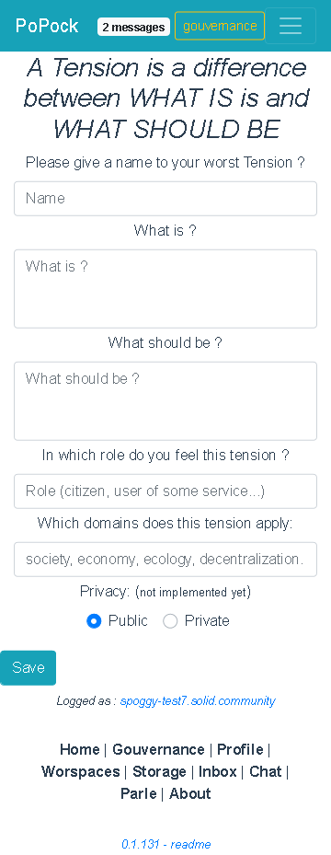

https://fr.wikipedia.org/wiki/Solid_(projet_de_web_d%C3%A9centralis%C3%A9) & https://solidproject.org/
https://www.w3.org/TR/ldp/
https://semapps.org/
http://data.persee.fr/
https://github.com/solid/solid-panes/blob/master/Documentation/conventions.md#long-chat

